BRAIN-TARGETED TEACHING
LEARNING UNIT

Teacher: Janice Vina G. Dotimas Dates: 8 weeks

Unit Topic/Title: “Human Impact on Marine Ecosystem”

Grade Level: 4th Grade

Content Standard(s):
Maryland State Curriculum;
(Science) IV. A.1 Recognize and describe that people in Maryland depend on, change, and are affected by the environment.
- Identify and describe that human activities in a community or region are affected by environmental factors
- Identify and describe personal and community behaviors that waste natural resources and/or cause environmental harm and those behaviors that maintain or improve the environment.
(Literacy) IV.I. A.4 Determine important ideas and messages in informational texts.
- State and support main ideas and messages.
- Summarize or paraphrase
(Writing) IV. I.A. 6 Compose oral, written, and visual presentations that express personal ideas, inform, and persuade
- Describe in prose and poetry by using purposeful imagery and sensory details with active verbs and colorful adjectives
- Compose to inform using a structure with a clear beginning, middle, and end and a selection of major points, examples, and facts to support a main idea
- Compose to persuade using significant reasons and relevant support
Brain Target#1
Emotional Connection
- The lessons will begin with a video on how humans impact the ecosystem focusing on the water. They will form in groups and synthesize what they have learned from the videos. They will make connections on how this affects them personally.
- In the classroom, after their BBK (Inner Harbor Trip), the students will work in groups and work together to make a list of what ifs… (i.e. . What if there were no signs on not to throw garbage on the water; what if the government will not spend, money on cleaning the harbor’s water?) This should be written on chart papers. Students should have the opportunity to share their connections using the Gallery Walk activity in which groups will have the opportunity to react what the other groups have listed. They can agree or disagree and they have to explain why.
- Journal Writing: For individual work to reflect on the water’s health: What can I do to help preserve the Inner Harbor’s water?
- Throughout the unit, it must be emphasized that each student has a role in the ecosystem and especially it will their responsibility to let others also know that it takes the whole community to do this.

Brain Target #2
Physical Environment
- The bulletin boards should be places where the students can hang their charts.
- Pictures of the video clips “Ecosystem” can be visible in the classroom.
- Computers will be available for research.
- Photography center is accessible to the students.
- Arrange for flexible seating that will lend itself to the many group activities that the unit will require.
- Journals should be in one place so if students will write on them, they will easy access and also, it will be a more focuses center.
- Since this is all about human impact on the ecosystem, there will be a “Collaboration Corner” where students will have the opportunity to confer and check for clarification with the teacher.
- A word wall should be interactive and progressive.
- Poem about “Watershed” should be part of Morning Message.

Brain Target #3
Concept Map/Advanced Organizer

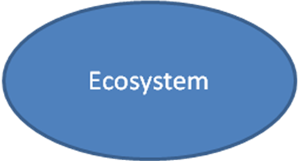

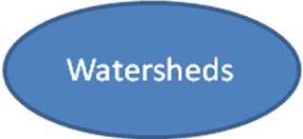

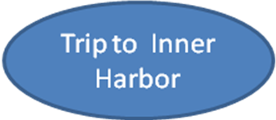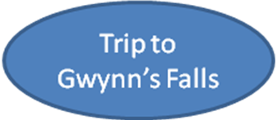
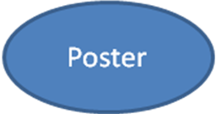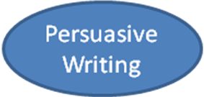

Learning Goals:
- I can analyze how humans have impacted the Gwynn’s Fall /Inner Harbor Watersheds
- I can explain what a watershed is and how it is connected to a larger body of water
- I can explain how a change in one part of a system changes the whole system
- I can write to inform using a persuasive form
- I can write a haiku about awareness of preserving the environment
- I can a photograph that will support my haiku content
- I can define the elements of an ecosystem
- I can explain what causes water pollution
Introductory “Big Picture” Activity/Assessment of Prior Knowledge:
For Building Background Knowledge (BBK), the students will go to the Inner Harbor with the purpose of taking pictures on how the government protects the harbor and how people take care or waste the water in the Inner Harbor. They will observe if these signs or effort were evident on taking care of watersheds.

Brain Target #4
Activities for Teaching Mastery of Declarative/ Procedural Knowledge:
- Students will use charts to illustrate what a watershed is
- Students will use facts from their note catchers in writing their paragraphs
- Students will take pictures of water drains
- Students will write haikus
- Students will make a manhole design to create awareness on how to make it free from garbage
- Students will read books from the A-Z Leveled Reading Books for guided reading groups to strengthen other reading skill deficiencies.
- Students will learn from guest speakers from Irvine Nature Center on the quality of water found in the Baltimore Area.
- Students will have an interactive symposium with Lauren from ‘the Baltimore Blue Waters
- Student will work with partners in different grades to study photography.

- Students will take a trip to Gwynn’s Falls on May 24/25 to take pictures for their Haikus.

Brain Target #5
Activities for Extension and Application of Knowledge

- Using the Persuasive Techniques in Advertising students will write a letter to a news agency to persuade the management to help them in their efforts to make the water clean in the Baltimore Area
- Student will work with partners in different grades to study photography.
- Students will put their haikus together. Haiku is the chosen poem that the students will write. They will take photographs on how people taking care/not taking care of water drains .They make it into a book. Have a book signing in Barnes and Nobles

Brain Target #6
Evaluating Learning
- Use rubrics for Writing a Persuasive Text: topics relevance , mechanics, content
Writing Rubrics
Checklist | Observed | Not  Observed | Not Applicable
Content is relevant to the course of study
Main Idea is clearly stated
Supporting details are evident
Tone is persuasive in nature
Capital letters are used correctly.
Punctuation is used.
Indention is proper.
- Use rubrics for poetry: Haiku form, picture relevance, “wow” effect : Bubble in if these items are evident:
- Photograph reflects the theme.
- Subject of the photograph using the rule of 3rd.
- Haiku follows the 5-7-5 pattern.
- “Wow” feeling is in effect.
- Reflection on their journal on how they can make an impact on the quality of water should be reflected.

Resources used:
- Reading A-Z Leveled reading Books
- EPA: Office of Water; Office of Wetland, Oceans, and Watersheds
- Blue Water Baltimore
- Website used: www. Epa.gov/owow/oceans/debris
- Irvine nature Center:www.explorenature.org
- Healthy Harbor Initiative

